

**Lab No: 4 Date: 2082/**

**Title: Write a program to calculate the average turnaround time and waiting time for user input process parameters using FCFS process scheduling algorithm.**

First Come First Serve (FCFS) is the simplest CPU scheduling algorithm. In this method, the process that arrives first in the ready queue is executed first. It follows the FIFO (First In First Out) principle, similar to a queue in real life.

Algorithm:

Step 1: Start with the list of processes and note their arrival time and burst time.

Step 2: Sort all processes in the order of their arrival time.

Step 3: Assign the CPU to the process that arrived first, then to the next, and so on.

Step 4: Calculate waiting time and turnaround time for each process.

Step 5: Compute the average waiting time and average turnaround time.

Step 6: Stop.

**Language**: C++

**IDE**: VS Code

**Code:**

**#include <iostream>**

**#include <vector>**

**using namespace std;**

**struct Job {**

**int pid;        // process id**

**int bt;         // burst time**

**int at;         // arrival time**

**int ct;         // completion time**

**int tat;        // turnaround time**

**int wt;         // waiting time**

**};**

**int main() {**

**int num;**

**cout << "Enter number of processes: ";**

**cin >> num;**

**vector<Job> tasks(num);**

**// All arrival times are zero**

**for (int i = 0; i < num; i++) {**

**tasks[i].pid = i + 1;**

**tasks[i].at = 0;**

**cout << "Enter burst time for process " << i + 1 << ": ";**

**cin >> tasks[i].bt;**

**}**

**// Calculate CT, TAT, WT**

**int time = 0;**

**for (int i = 0; i < num; i++) {**

**if (time < tasks[i].at)**

**time = tasks[i].at;**

**time += tasks[i].bt;**

**tasks[i].ct = time;**

**tasks[i].tat = tasks[i].ct - tasks[i].at;**

**tasks[i].wt = tasks[i].tat - tasks[i].bt;**

**}**

**// Gantt Chart**

**cout << "\nGantt Chart:\n|";**

**time = 0;**

**for (int i = 0; i < num; i++) {**

**cout << "  P" << tasks[i].pid << "\t|";**

**}**

**cout << "\n0";**

**for (int i = 0; i < num; i++) {**

**time += tasks[i].bt;**

**cout << "     \t" << time;**

**}**

**cout << "\n";**

**// Final result table**

**cout << "\nProcess\tBT\tAT\tCT\tTAT (CT-AT)\tWT (TAT-BT)\n";**

**double sumTAT = 0, sumWT = 0;**

**for (int i = 0; i < num; i++) {**

**cout << "  P" << tasks[i].pid << "\t";**

**cout<< tasks[i].bt << "\t";**

**cout<< tasks[i].at << "\t";**

**cout<< tasks[i].ct << "\t";**

**cout<< tasks[i].ct << "-" << tasks[i].at;**

**cout<< "=" << tasks[i].tat << "\t\t";**

**cout<< tasks[i].tat << "-" << tasks[i].bt;**

**cout<< "=" << tasks[i].wt << "\n";**

**sumTAT += tasks[i].tat;**

**sumWT += tasks[i].wt;**

**}**

**cout << "\nAverage Turnaround Time = " << sumTAT / num;**

**cout << "\nAverage Waiting Time = " << sumWT / num << "\n";**

**return 0;**

**}**

**Output:**

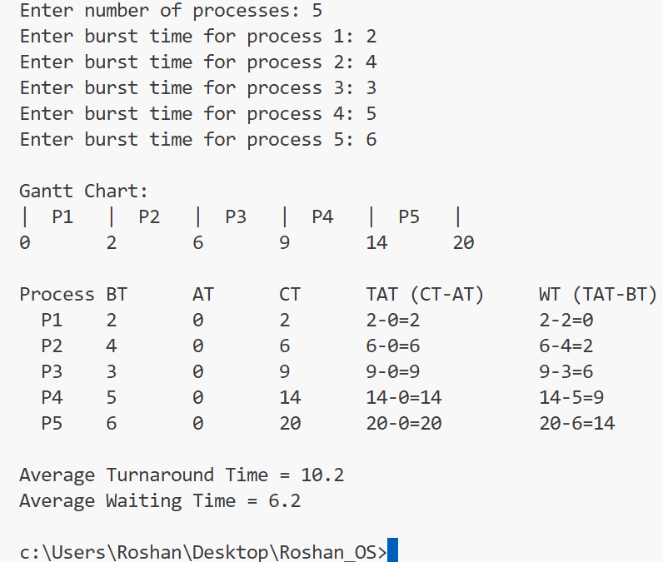

**Conclusion:**

FCFS is simple and fair because every process is executed in the order of arrival. However, it can cause the convoy effect (a long process delays all others). It works well for smaller systems with fewer processes but is not always efficient for modern multitasking operating systems.